EF Core 8.0 (Labs 1–5)
Lab 1:
Understanding ORM with a Retail Inventory System
ORM:
ORM is a technique that connects the rich objects of an application (like C# classes) to tables in a relational database, automating the conversion (mapping) between them.
How it works in C#:
· Each class in C# corresponds to a table in the database.
· Each property in the class maps to a column.
· Relationships like one-to-many, many-to-many are represented using navigation properties and foreign keys.
EF Core vs EF Framework:
Feature | EF Core | EF Framework (EF6)
Platform | Cross-platform (.NET Core, .NET 6/7/8) | Windows-only
Performance | Lightweight and faster | Heavier
Modern Features | LINQ, async, compiled queries | Limited async support
Maturity | Still evolving | More mature/stable
Migration Support | Yes | Yes
Usage | Recommended for new apps | Legacy support only

EF Core 8.0 Features:
JSON Column Mapping:
Store complex types like lists/dictionaries as JSON in a single column.
Compiled Models:
Faster startup time; reduces runtime overhead by pre-compiling model metadata.
Interceptors:
Hook into database operations (e.g., logging, modifying commands).
Bulk Operations:
Improved support for batching INSERT/UPDATE/DELETE.
Create a .NET Console App:
bash
CopyEdit
dotnet new console -n RetailInventorycd RetailInventory
Install EF Core Packages for SQL Server:
bash
CopyEdit
dotnet add package Microsoft.EntityFrameworkCore.SqlServer
Lab 2:
Setting Up the Database Context for a Retail Store
Create Models:
public class Category
{
public int Id { get; set; }
public string Name { get; set; }
public List<Product> Products { get; set; }
}
public class Product
{
public int Id { get; set; }
public string Name { get; set; }
public decimal Price { get; set; }
public int CategoryId { get; set; }
public Category Category { get; set; }
}
Create AppDbContext:

using Microsoft.EntityFrameworkCore;

public class AppDbContext : DbContext
{
public DbSet<Product> Products { get; set; }
public DbSet<Category> Categories { get; set; }

protected override void OnConfiguring(DbContextOptionsBuilder optionsBuilder)
{
optionsBuilder.UseSqlServer("Server=localhost;Database=RetailDb;Trusted_Connection=True;");
}
}
Optional (For ASP.NET Core): Use appsettings.json:

In ASP.NET Core apps, it’s better to configure the connection string in appsettings.json:
json
CopyEdit
{
"ConnectionStrings": {
"DefaultConnection": "Server=localhost;Database=RetailDb;Trusted_Connection=True;"
}}
Then configure it in Program.cs or Startup.cs:
csharp
CopyEdit
builder.Services.AddDbContext<AppDbContext>(options =>
options.UseSqlServer(builder.Configuration.GetConnectionString("DefaultConnection")));
Lab 3:
Using EF Core CLI to Create and Apply Migrations

Install EF Core CLI:
dotnet tool install --global dotnet-ef
Create the Initial Migration:
dotnet ef migrations add InitialCreate
Apply the Migration and Create the Database:
dotnet ef database update

Verify in SQL Server:
Open SQL Server Management Studio (SSMS) or Azure Data Studio.
Connect to the server instance mentioned in your connection string.
Check if the database exists (e.g., RetailDb).
Expand Tables – you should see:
Categories
Products
__EFMigrationsHistory (EF Core internal)

Lab 4:
Inserting Initial Data into the Database

Insert Data in Program.cs:

Program.cs:
using System;
using System.Threading.Tasks;
using Microsoft.EntityFrameworkCore;
class Program
{
static async Task Main(string[] args)
{
using var context = new AppDbContext();
var electronics = new Category { Name = "Electronics" };
var groceries = new Category { Name = "Groceries" };
await context.Categories.AddRangeAsync(electronics, groceries);
var product1 = new Product { Name = "Laptop", Price = 75000, Category = electronics };
var product2 = new Product { Name = "Rice Bag", Price = 1200, Category = groceries };
await context.Products.AddRangeAsync(product1, product2);
await context.SaveChangesAsync();
Console.WriteLine("Initial data inserted successfully!");
}
}

Run the Application:

dotnet run
Initial data inserted successfully!

Verify in SQL Server:
SELECT * FROM Categories;
SELECT * FROM Products;
Lab 5:
Retrieving Data from the Database

Program.cs:
using System;
using System.Threading.Tasks;
using Microsoft.EntityFrameworkCore;
class Program
{
static async Task Main(string[] args)
{
using var context = new AppDbContext();
Console.WriteLine("\n All Products:");
var products = await context.Products.ToListAsync();
foreach (var p in products)
Console.WriteLine($"{p.Name} - ₹{p.Price}");
Console.WriteLine("\n Find Product by ID (1):");
var product = await context.Products.FindAsync(1);
Console.WriteLine($"Found: {product?.Name}");
Console.WriteLine("\n First Product with Price > ₹50000:");
var expensive = await context.Products.FirstOrDefaultAsync(p => p.Price > 50000);
Console.WriteLine($"Expensive: {expensive?.Name}");
}
}
Output:

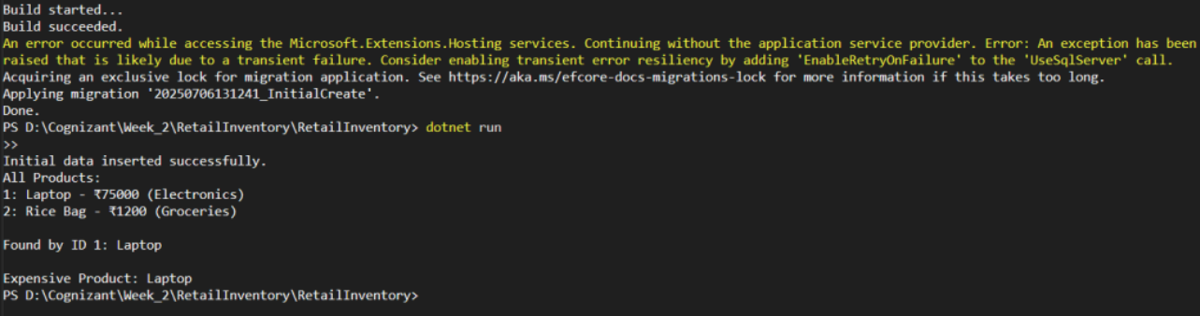
Lab 6:
Updating and Deleting Records

Program.cs:
using System;
using System.Threading.Tasks;
using Microsoft.EntityFrameworkCore;
class Program
{
static async Task Main(string[] args)
{
using var context = new AppDbContext();
var product = await context.Products.FirstOrDefaultAsync(p => p.Name == "Laptop");
if (product != null)
{
Console.WriteLine($"Before Update: {product.Name} - ₹{product.Price}");
product.Price = 70000;
await context.SaveChangesAsync();
Console.WriteLine($"After Update: {product.Name} - ₹{product.Price}");
}
var toDelete = await context.Products.FirstOrDefaultAsync(p => p.Name == "Rice Bag");
if (toDelete != null)
{
context.Products.Remove(toDelete);
await context.SaveChangesAsync();
Console.WriteLine($"Deleted: {toDelete.Name}");
}
Console.WriteLine("\n📦 Updated Product List:");
var products = await context.Products.ToListAsync();
foreach (var p in products)
Console.WriteLine($"{p.Name} - ₹{p.Price}");
}
}
Output:

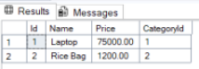

Lab 7:
Writing Queries with LINQ

Program.cs
using System;
using System.Threading.Tasks;
using System.Linq;
using Microsoft.EntityFrameworkCore;
class Program
{
static async Task Main(string[] args)
{
using var context = new AppDbContext();

var filtered = await context.Products
.Where(p => p.Price > 1000)
.OrderByDescending(p => p.Price)
.ToListAsync();
Console.WriteLine("\n📊 Filtered & Sorted Products (Price > ₹1000):");
foreach (var p in filtered)
Console.WriteLine($"{p.Name} - ₹{p.Price}");
var productDTOs = await context.Products
.Select(p => new { p.Name, p.Price })
.ToListAsync();
Console.WriteLine("\n📄 Product DTOs (Name + Price only):");
foreach (var dto in productDTOs)
Console.WriteLine($"{dto.Name} - ₹{dto.Price}");
}
}
Output:

